
Media Contact: Danielle Mulholland
Litzky Public Relations
(201) 222-9118
dmulholland@litzkypr.com

HASBRO STAR WARS: THE BLACK SERIES UPDATED PACKAGING 2020 ONE SHEET

The new Star Wars: The Black Series packaging featured below welcomes a new era for collectors and fans, featuring several new details and colorways. Each colorway represents a Star Wars entertainment property and helps fans to collect figures based on their favorite Star Wars movies and series. The side of the new Star Wars: The Black Series packaging also highlights new character art for each figure. The combination of the colorways and character art allows fans to create amazing montage-style displays of their favorite Star Wars characters.
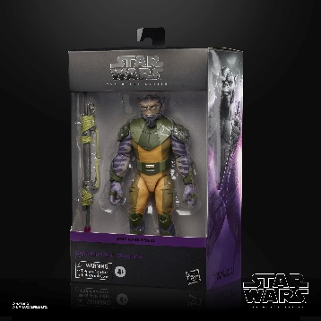
STAR WARS: THE BLACK SERIES 6-INCH GARAZEB “ZEB” ORRELIOS DELUXE Figure
(HASBRO/Ages 4 years & up/Approx. Retail Price: $29.99/Available: Fall 2020)
Fans and collectors can imagine scenes from the STAR WARS Galaxy with this quality STAR WARS: THE BLACK SERIES 6-INCH GARAZEB “ZEB” ORRELIOS DELUXE Figure, inspired by the STAR WARS REBELS animated series. This figure also comes with a GARAZEB “ZEB” ORRELIOS-inspired accessory that makes a great addition to any STAR WARS collection. STAR WARS fans and collectors can display this highly poseable (4 fully articulated limbs) figure, featuring premium deco, in their action figure and vehicle collection. Includes figure and accessory. Available for pre-order at GameStop, Hasbro Pulse, and Entertainment Earth.
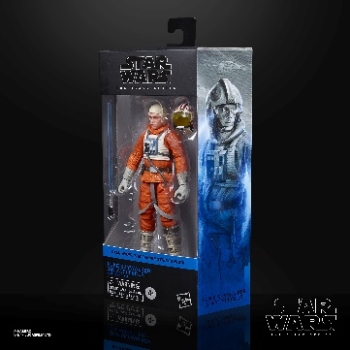
STAR WARS: THE BLACK SERIES 6-INCH LUKE SKYWALKER (SNOWSPEEDER) Figure
(HASBRO/Ages 4 years & up/Approx. Retail Price: $19.99/Available: Fall 2020)
Fans and collectors can imagine scenes from the STAR WARS Galaxy with this quality STAR WARS: THE BLACK SERIES 6-INCH LUKE SKYWALKER (SNOWSPEEDER) Figure, inspired by STAR WARS: THE EMPIRE STRIKES BACK. This figure comes with 2 LUKE SKYWALKER (SNOWSPEEDER)-inspired accessories that make great additions to any STAR WARS collection. STAR WARS fans and collectors can display this highly poseable (4 fully articulated limbs) figure, featuring premium deco, in their action figure and vehicle collection. Includes figure and 2 accessories. Available for pre-order at Amazon, Walmart, Hasbro Pulse, and Entertainment Earth.
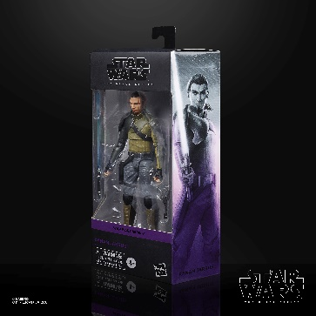
STAR WARS: THE BLACK SERIES 6-INCH KANAN JARRUS Figure
(HASBRO/Ages 4 years & up/Approx. Retail Price: $19.99/Available: Fall 2020)
Fans and collectors can imagine scenes from the STAR WARS Galaxy with this quality STAR WARS: THE BLACK SERIES 6-INCH KANAN JARRUS Figure, inspired by the STAR WARS REBELS animated series. This figure comes with 2 KANAN JARRUS-inspired accessories that make great additions to any STAR WARS collection. STAR WARS fans and collectors can display this highly poseable (4 fully articulated limbs) figure, featuring premium deco, in their action figure and vehicle collection. Includes figure and 2 accessories. Available for pre-order at GameStop, Hasbro Pulse, and Entertainment Earth.
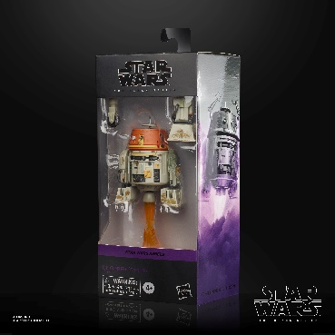
STAR WARS: THE BLACK SERIES 6-INCH CHOPPER (C1-10P) Figure
(HASBRO/Ages 4 years & up/Approx. Retail Price: $19.99/Available: Fall 2020)
Fans and collectors can imagine scenes from the STAR WARS Galaxy with this quality STAR WARS: THE BLACK SERIES 6-INCH CHOPPER (C1-10P) Figure, inspired by the STAR WARS REBELS animated series. This figure comes with 2 CHOPPER (C1-10P)-inspired accessories that make great additions to any STAR WARS collection. STAR WARS fans and collectors can display this highly poseable (4 fully articulated limbs) figure, featuring premium deco, in their action figure and vehicle collection. Includes figure and 2 accessories. Available for pre-order at Amazon, GameStop, Hasbro Pulse, and Entertainment Earth.

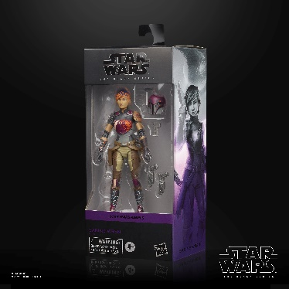
STAR WARS: THE BLACK SERIES 6-INCH SABINE WREN Figure
(HASBRO/Ages 4 years & up/Approx. Retail Price: $19.99/Available: Fall 2020)
Fans and collectors can imagine scenes from the STAR WARS Galaxy with this quality STAR WARS: THE BLACK SERIES 6-INCH SABINE WREN Figure, inspired by the STAR WARS REBELS animated series. This figure comes with 3 SABINE WREN-inspired accessories that make great additions to any STAR WARS collection. STAR WARS fans and collectors can display this highly poseable (4 fully articulated limbs) figure, featuring premium deco, in their action figure and vehicle collection. Includes figure and 3 accessories. Available for pre-order at Amazon, GameStop, Hasbro Pulse, and Entertainment Earth.
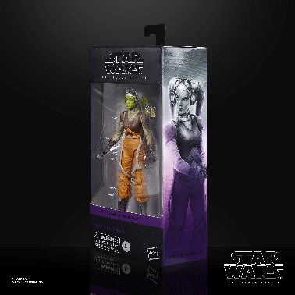
STAR WARS: THE BLACK SERIES 6-INCH HERA SYNDULLA Figure
(HASBRO/Ages 4 years & up/Approx. Retail Price: $19.99/Available: Fall 2020)
Fans and collectors can imagine scenes from the STAR WARS Galaxy with this quality STAR WARS: THE BLACK SERIES 6-INCH HERA SYNDULLA Figure, inspired by the STAR WARS REBELS animated series. This figure comes with a HERA SYNDULLA-inspired accessory that makes a great addition to any STAR WARS collection. STAR WARS fans and collectors can display this highly poseable (4 fully articulated limbs) figure, featuring premium deco, in their action figure and vehicle collection. Includes figure and accessory. Available for pre-order at Amazon, GameStop, Hasbro Pulse, and Entertainment Earth.
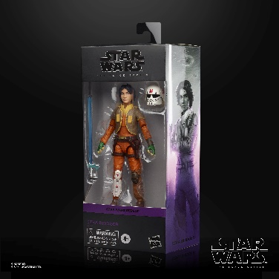
STAR WARS: THE BLACK SERIES 6-INCH EZRA BRIDGER Figure
(HASBRO/Ages 4 years & up/Approx. Retail Price: $19.99/Available: Fall 2020)
Fans and collectors can imagine scenes from the STAR WARS Galaxy with this quality STAR WARS: THE BLACK SERIES 6-INCH EZRA BRIDGER Figure, inspired by the STAR WARS REBELS animated series. This figure comes with 2 EZRA BRIDGER-inspired accessories that make great additions to any STAR WARS collection. STAR WARS fans and collectors can display this highly poseable (4 fully articulated limbs) figure, featuring premium deco, in their action figure and vehicle collection. Includes figure and 2 accessories. Available for pre-order at Amazon, GameStop, Hasbro Pulse, and Entertainment Earth.
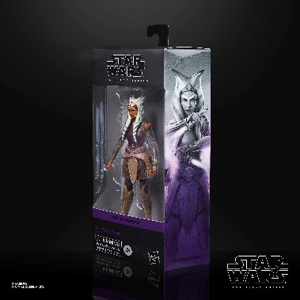
STAR WARS: THE BLACK SERIES 6-INCH AHSOKA TANO Figure
(HASBRO/Ages 4 years & up/Approx. Retail Price: $19.99/Available: Fall 2020)
Fans and collectors can imagine scenes from the STAR WARS Galaxy with this quality STAR WARS: THE BLACK SERIES 6-INCH AHSOKA TANO Figure, inspired by the STAR WARS REBELS animated series. This figure comes with 2 AHSOKA TANO-inspired accessories that make great additions to any STAR WARS collection. STAR WARS fans and collectors can display this highly poseable (4 fully articulated limbs) figure, featuring premium deco, in their action figure and vehicle collection. Includes figure and 2 accessories. Available for pre-order at Amazon, GameStop, Hasbro Pulse, and Entertainment Earth.
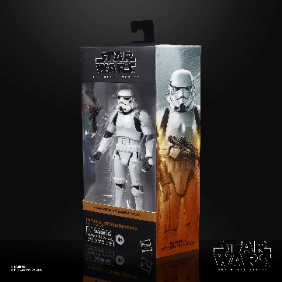
STAR WARS: THE BLACK SERIES 6-INCH IMPERIAL STORMTROOPER Figure
(HASBRO/Ages 4 years & up/Approx. Retail Price: $19.99/Available: Fall 2020)
Fans and collectors can imagine scenes from the STAR WARS Galaxy with this STAR WARS: THE BLACK SERIES 6-INCH IMPERIAL STORMTROOPER Figure, inspired by The Mandalorian series on Disney Plus and featuring quality detail and multiple points of articulation. STAR WARS fans and collectors can display this highly poseable (4 fully articulated limbs) figure, featuring premium deco, in their action figure and vehicle collection. Includes figure and accessory. Available for pre-order at Amazon, Walmart, GameStop, Hasbro Pulse, Entertainment Earth

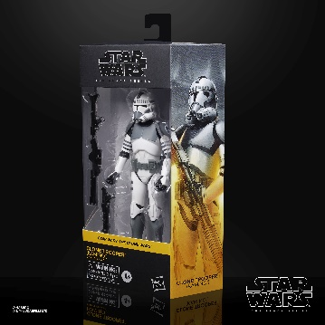
STAR WARS: THE BLACK SERIES 6-INCH CLONE TROOPER (KAMINO) Figure
(HASBRO/Ages 4 years & up/Approx. Retail Price: $19.99/Available: Fall 2020)
Fans and collectors can imagine scenes from the STAR WARS Galaxy with this STAR WARS: THE BLACK SERIES 6-INCH CLONE TROOPER (KAMINO) Figure, inspired by the STAR WARS: THE CLONE WARS series and featuring quality detail and multiple points of articulation. STAR WARS fans and collectors can display this highly poseable (4 fully articulated limbs) figure, featuring premium deco, in their action figure and vehicle collection. Includes figure and 2 accessories. Available for pre-order at Amazon, Walmart, GameStop, Hasbro Pulse, and Entertainment Earth.
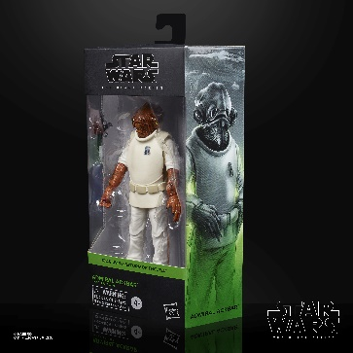
STAR WARS: THE BLACK SERIES 6-INCH ADMIRAL ACKBAR Figure
(HASBRO/Ages 4 years & up/Approx. Retail Price: $19.99/Available: Fall 2020)
Fans and collectors can imagine scenes from the STAR WARS Galaxy with this STAR WARS: THE BLACK SERIES 6-INCH ADMIRAL ACKBAR Figure, designed to look like the character from STAR WARS: RETURN OF THE JEDI and featuring premium detail and multiple points of articulation. STAR WARS fans and collectors can display this highly poseable (4 fully articulated limbs) figure, featuring movie-inspired deco, in their action figure and vehicle collection. Includes figure and accessory. Available for pre-order at Amazon, Walmart, GameStop, Hasbro Pulse, and Entertainment Earth.
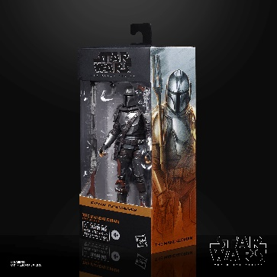
STAR WARS: THE BLACK SERIES 6-INCH THE MANDALORIAN Figure
(HASBRO/Ages 4 years & up/Approx. Retail Price: $19.99/Available: Fall 2020)
Fans and collectors can imagine scenes from the STAR WARS Galaxy with this premium STAR WARS: THE BLACK SERIES 6-INCH THE MANDALORIAN Figure is carefully detailed to look like the character from THE MANDALORIAN live-action TV series on Disney Plus. Featuring premium deco and multiple points of articulation, STAR WARS fans and collectors can display this highly poseable (4 fully articulated limbs) figure in their action figure and vehicle collection. Includes figure and 3 accessories. Available for pre-order at Amazon, Walmart, GameStop, Hasbro Pulse, and Entertainment Earth.
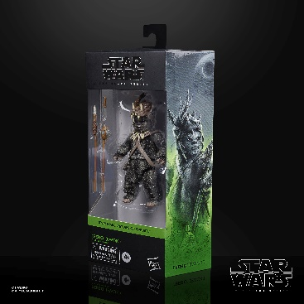
STAR WARS: THE BLACK SERIES 6-INCH TEEBO (EWOK) Figure
(HASBRO/Ages 4 years & up/Approx. Retail Price: $19.99/Available: Fall 2020)
Fans and collectors can imagine scenes from the STAR WARS Galaxy with this STAR WARS: THE BLACK SERIES 6-INCH TEEBO (EWOK) Figure, which is detailed to look like the character from STAR WARS: RETURN OF THE JEDI. Featuring premium deco and multiple points of articulation, STAR WARS fans and collectors can display this highly poseable (4 fully articulated limbs) figure in their action figure and vehicle collection. Includes figure and 3 accessories. Available for pre-order at Amazon, Walmart, GameStop, Hasbro Pulse, and Entertainment Earth.
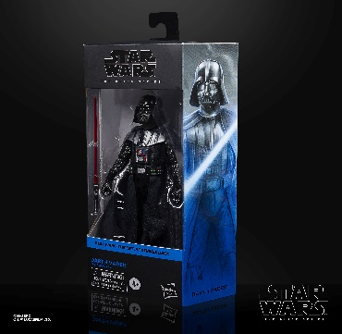
STAR WARS: THE BLACK SERIES 6-INCH DARTH VADER Figure
(HASBRO/Ages 4 years & up/Approx. Retail Price: $19.99/Available: Fall 2020)
Fans and collectors can imagine scenes from the STAR WARS Galaxy with this STAR WARS: THE BLACK SERIES 6-INCH DARTH VADER Figure, which is detailed to look like the character from STAR WARS: THE EMPIRE STRIKES BACK. Featuring premium deco and multiple points of articulation, STAR WARS fans and collectors can display this highly poseable (4 fully articulated limbs) figure in their action figure and vehicle collection. Includes figure and accessory. Available for pre-order at Amazon, Walmart, GameStop, Hasbro Pulse, and Entertainment Earth.

*The full Hasbro Star Wars: The Black Series 6-Inch wave is available for pre-order at Entertainment Earth.
# # #

